ASR 6140

Inbound and outbound Order Summary report

Request description:

To enable retrieve Inbound and outbound order summary report to analyze operation demand and have better deployment

WMS changes:

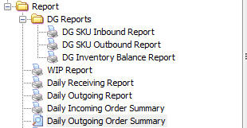

1. Daily Incoming summary report

Retrieve by Date range

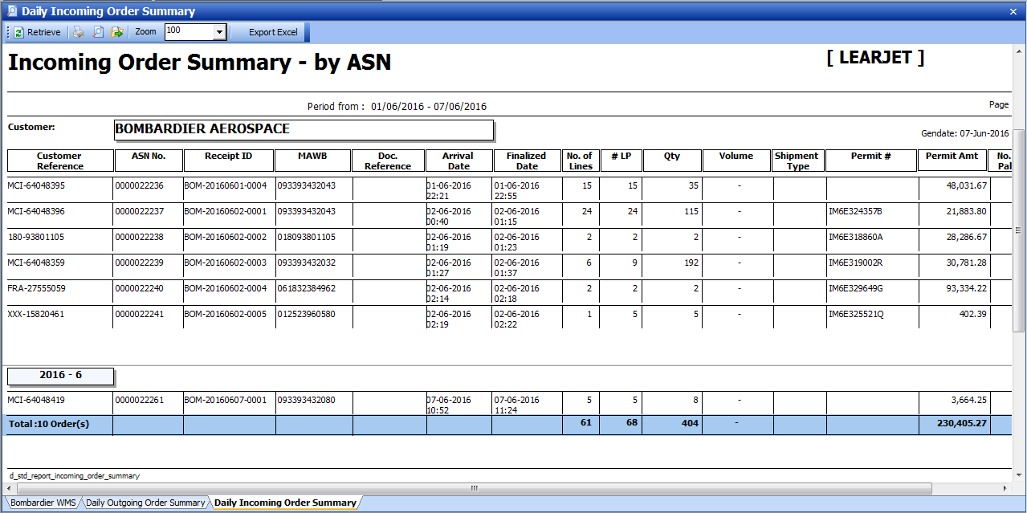

1. Daily Outgoing summary report

Retrieve by Date range

